

**CAPSTONE pROJECT**

**MOVIE RENTAL ANALYTICS**



**NAME: SHIVANI tUMBA**

**Project Overview**

The objective of this project is to create a comprehensive Power BI dashboard using the Sakila DVD Rental Store Database, providing valuable insights into the rental store business. This project aims to facilitate data-driven decision-making and enhance overall business performance by leveraging advanced data analytics and visualization techniques.

**Analysis Focus Areas**

1. **Customer Behaviour**: Understanding customer preferences, rental patterns, and demographics.
2. **Film Inventory Management**: Optimizing film inventory to meet customer demand and reduce stockouts.
3. **Staff Performance**: Evaluating staff productivity, efficiency, and service quality.
4. **Store Operations**: Streamlining store processes to improve operational efficiency and reduce costs.

**Goals**

The primary goals of this project include:

* **Data-Driven Decision-Making**: Empowering store owners with actionable insights for informed decision-making.
* **Optimizing Film Inventory**: Ensuring the right films are available at the right time to meet customer demand.
* **Enhancing Customer Satisfaction**: Improving customer experience through targeted marketing and personalized recommendations.
* **Improving Staff Performance**: Identifying training needs and recognizing top-performing staff.
* **Streamlining Store Operations**: Enhancing operational efficiency and reducing operational costs.

**Power BI Dashboard Insights**

The Power BI dashboard will provide valuable insights into the following areas:

* **Customer Segmentation**: Identifying different customer segments based on rental behaviour and demographics.
* **Sales Trends**: Analysing rental revenue trends over time to identify peak periods and seasonal patterns.
* **Film Performance**: Evaluating the popularity and rental frequency of films to optimize the film collection.
* **Staff Productivity**: Assessing staff performance metrics such as rental transactions per staff member.
* **Store Revenue**: Monitoring store revenue and identifying key revenue drivers.

**Exploratory Data Analysis (EDA)**

EDA will be a crucial part of this project to uncover hidden patterns, trends, and relationships within the data. The EDA process will include:

* **Data Cleaning**: Identifying and handling missing values, outliers, and inconsistencies in the data.
* **Data Visualization**: Creating visual representations of the data to understand distributions and relationships.
* **Descriptive Statistics**: Calculating summary statistics such as mean, median, mode, and standard deviation.
* **Correlation Analysis**: Identifying correlations between different variables to uncover potential relationships.
* **Feature Engineering**: Creating new features based on existing data to enhance the analysis.

**Actionable Recommendations**

Based on the analysis, the dashboard will provide actionable recommendations to improve business performance, including:

* **Targeted Marketing Campaigns**: Designing marketing strategies for different customer segments.
* **Film Collection Enhancements**: Updating the film inventory based on popularity and rental trends.
* **Staff Training Initiatives**: Developing training programs to improve staff skills and performance.

**Final Deliverables**

The final deliverables will include:

1. **Power BI Dashboard**: An interactive dashboard with real-time data visualization and insights.
2. **Report**: A detailed report summarizing the findings and recommendations from the analysis.
3. **Presentation**: A presentation showcasing the dashboard’s insights and actionable recommendations.

**Project Steps**

1.**Data Collection from GitHub**: The initial step involves gathering data from the Sakila DVD Rental Store Database hosted on GitHub. This dataset contains information about customers, rentals, films, staff, and stores.

2.**Data Transformation**: Transform the collected raw data into a structured format suitable for analysis. This step includes normalizing data, creating relationships between tables, and ensuring data integrity.

3.**Data Cleaning**: Identify and handle missing values, outliers, and inconsistencies in the data to ensure the accuracy and reliability of the analysis.

4.**MECE Breakdown**: Perform a MECE (Mutually Exclusive, Collectively Exhaustive) breakdown of the data to categorize and organize the information into distinct, non-overlapping segments. This helps in systematically addressing all aspects of the analysis.

5.**Connecting with Tools**: Establish connections between the cleaned and transformed data and the analytical tools used in the project, such as Power BI, for visualization and analysis.

6.**Exploratory Data Analysis (EDA)**: Conduct EDA to uncover hidden patterns, trends, and relationships within the data. The EDA process includes:

* **Data Cleaning**: Reiterating the importance of handling missing values, outliers, and inconsistencies.
* **Data Visualization**: Creating visual representations to understand distributions and relationships.
* **Descriptive Statistics**: Calculating summary statistics like mean, median, mode, and standard deviation.
* **Correlation Analysis**: Identifying correlations between variables to uncover potential relationships.
* **Feature Engineering**: Creating new features based on existing data to enhance the analysis.

7.**Power BI Analysis**: Utilize Power BI to create an interactive dashboard with real-time data visualization. The dashboard will provide insights into customer segmentation, sales trends, film performance, staff productivity, and store revenue.

8.**Documentation**: Prepare a detailed report summarizing the findings and recommendations from the analysis. The report will include data sources, methodologies, analysis results, and actionable insights.

9.**Presentation**: Create a presentation showcasing the dashboard’s insights and actionable recommendations. The presentation will be used to communicate the findings to stakeholders and guide decision-making.

**Dataset Description**

The dataset described is a comprehensive database. It comprises multiple tables, each representing different entities and their relationships. Taking a closer look at the key components of the dataset:

**1. Actor**

* **Columns**: Actor_id (Primary Key), First_name, Last_name, Last_update

**Description**: This table contains information about the actors in the films, including their names and the last update timestamp.

**2. Address**

* **Columns**: Address_id (Primary Key), Address, District, City_id (Foreign Key), Postal_code, Phone, Location, Last_update

**Description**: This table stores address details for customers, staff, and stores, including city references and contact information.

**3. Category**

* **Columns**: Category_id (Primary Key), Name, Last_update

**Description**: This table categorizes films into different genres, with the category name and last update timestamp.

**4. City**

* **Columns**: City_id (Primary Key), City, Country_id (Foreign Key),

Last_update

**Description**: This table contains city information, including the country references and last update timestamp.

**5. Country**

* **Columns**: Country_id (Primary Key), Country, Last_update

**Description**: This table holds country names and the last update timestamp.

**6. Customer**

* **Columns**: Customer_id (Primary Key), Store_id (Foreign Key),

First_name, Last_name, Email, Address_id (Foreign Key), Active,

Create_date, Last_update

**Description**: This table includes customer information, store affiliations, and contact details.

**7. Film**

* **Columns**: Film_id (Primary Key), Title, Description, Release_year,

Language_id (Foreign Key), Original_language, Rental_duration,

Rental_rate, Length, Replacement_cost, Rating, Special_features,

Last_update

**Description**: This table stores detailed information about films, including their titles, descriptions, languages, and rental details.

**8. Film Actor**

* **Columns**: Actor_id (Primary Key, Foreign Key), Film_id (Primary Key, Foreign Key), Last_update

**Description**: This table links actors to films, establishing a many-to-many relationship between them.

**9. Film Category**

* **Columns**: Film_id (Primary Key, Foreign Key), Category_id (Primary Key, Foreign Key), Last_update

**Description**: This table associates films with categories, defining the genres for each film.

**10. Film Text**

* **Columns**: Film_id (Primary Key), Title, Description

**Description**: This table stores textual descriptions and titles of films.

**11. Inventory**

* **Columns**: Inventory_id (Primary Key), Film_id (Foreign Key),

Store_id (Foreign Key), Last_update

**Description**: This table manages the inventory of films available in different stores, including their availability and last update timestamp.

**12. Language**

* **Columns**: Language_id (Primary Key), Name, Last_update

**Description**: This table holds information about the languages in which films are available.

**13. Payment**

* **Columns**: Payment_id (Primary Key), Customer_id (Foreign Key),

Staff_id (Foreign Key), Rental_id (Foreign Key), Amount,

Payment_date, Last_update

**Description**: This table records payment transactions, including customer, staff, rental references, and payment details.

**14. Rental**

* **Columns**: Rental_id (Primary Key), Rental_date, Inventory_id (Foreign Key), Customer_id (Foreign Key), Return_date, Staff_id (Foreign Key),

Last_update

**Description**: This table tracks the rental transactions, including rental dates, return dates, and associated customer and staff information.

**15. Staff**

* **Columns**: Staff_id (Primary Key), Name, Address_id (Foreign Key), Email, Store_id (Foreign Key), Active, Username, Last_update

**Description**: This table contains staff information, including contact details, store affiliations, and usernames.

**16. Store**

* **Columns**: Store_id (Primary Key), Manager_staff_id (Foreign Key),

Address_id (Foreign Key), Last_update

**Description**: This table includes store information, including manager and address references.

**MECE Breakdown**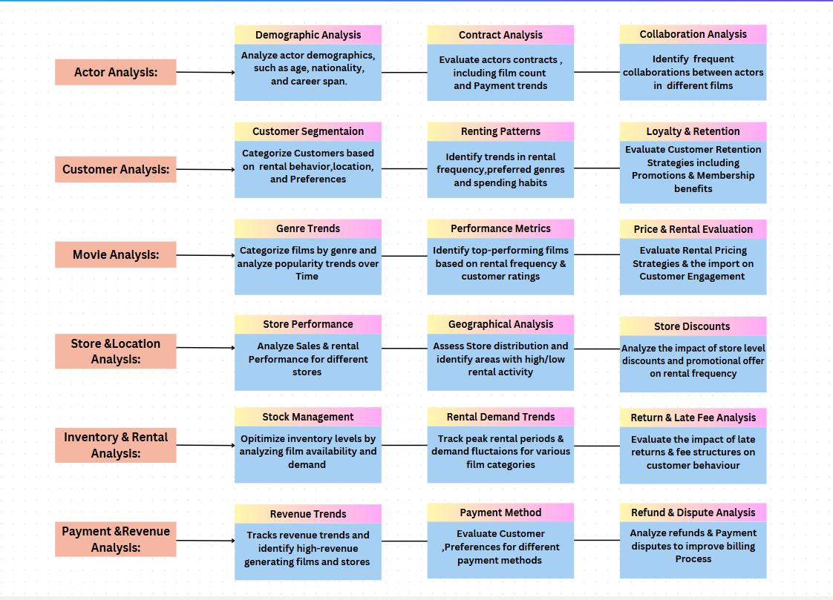

**Entity Relationship (ER) Diagram**

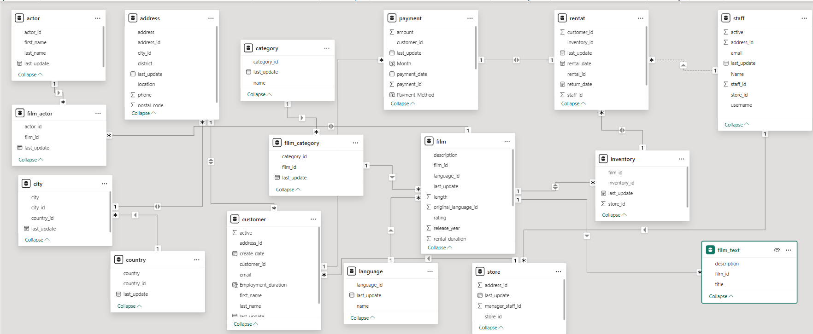

**Exploratory Data Analysis (EDA)**

**Questions:**

1. **What are the purchasing patterns of new customers versus repeat customers?**

**SQL-Query**

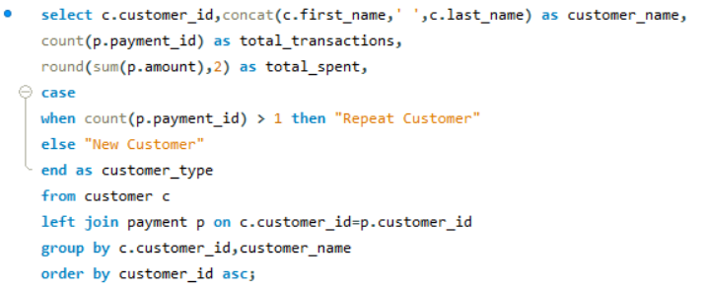

**Visualization**

**Insights:**

In conclusion, the comprehensive analysis of customer transactions through SQL queries and visualization techniques has yielded significant insights into consumer behaviour. The SQL query was designed to differentiate between new and repeat customers by counting their transactions and calculating total spending. This distinction is crucial for businesses aiming to understand their customer base and tailor their strategies accordingly.

The bar chart visualization further enriched our understanding by showcasing the variations in transaction numbers among different customer segments. It clearly illustrated the purchasing patterns, highlighting the differences between new and repeat customers. This visual representation made it easier to grasp the data and draw meaningful conclusions.

By leveraging these analytical methods, businesses can gain a deeper understanding of their customers' buying habits. This information is invaluable for developing targeted marketing campaigns, optimizing customer service, and improving overall business strategies. Understanding the unique needs and preferences of both new and repeat customers allows businesses to create personalized experiences that foster customer loyalty and drive growth.

In summary, the combination of SQL query analysis and data visualization provides a powerful toolset for businesses to analyse customer transactions and make informed decisions. These insights not only enhance customer satisfaction but also contribute to the long-term success of the business.

**2.Which films have the highest rental rates and are most in demand?**

**SQL Query**

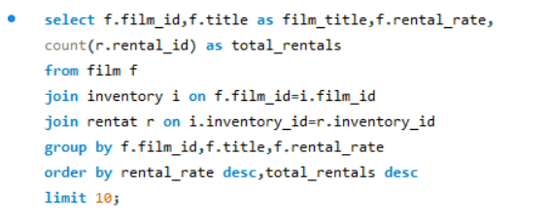

**Visualization**

**Insights:**

Analysing the rental rates and demand for films in our database has provided valuable insights into consumer preferences and market trends. By employing an SQL query, we successfully identified the top 10 films with the highest rental rates and the greatest demand. The query aggregated data on film titles, rental rates, and the total number of rentals, allowing us to rank the films accordingly.

The bar chart visualization further enhanced our understanding by graphically representing the rental rates and total rentals for these top films. This visualization clearly highlights which films are most popular among customers and have the highest rental rates, making it easier to identify patterns and trends in consumer behaviour.

The films "WITCHES PANIC," "CAT CONEHEADS," and "DOGMA FAMILY" emerged as the top three, showcasing a combination of high rental rates and significant demand. This information is crucial for businesses in the entertainment industry, as it helps them make informed decisions about inventory management, marketing strategies, and future film acquisitions.

In summary, the combination of SQL query analysis and data visualization has provided a comprehensive view of the films that are driving revenue and attracting customer interest. These insights are invaluable for optimizing business strategies and ensuring that the right films are available to meet customer demand.

**3.** **Are there correlations between staff performance and customer satisfaction?**

**SQL Query**

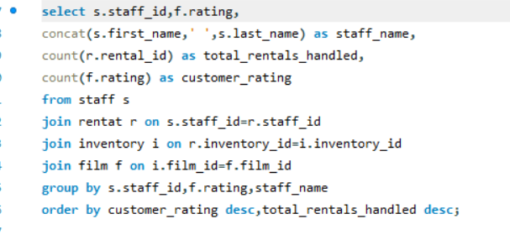

**Visualization**

**Insights:**

Analysing the correlation between staff performance and customer satisfaction through a detailed SQL query and visualization has provided invaluable insights. The SQL query was meticulously crafted to join various tables, allowing us to extract data on staff performance, customer ratings, and rental transactions. By grouping and aggregating the data, we could calculate the total rentals handled by each staff member and their respective customer ratings.

The bar chart visualization effectively highlighted the relationship between these two metrics. By comparing the total rentals handled (represented by blue bars) and customer ratings (represented by orange bars) for staff members such as Mike Hillyer and Jon Stephens across different film ratings (PG-13, PG, NC-17, R, G), we could discern clear patterns. The visualization showed a general trend where higher customer ratings were associated with higher total rentals handled. This suggests a positive correlation between staff performance and customer satisfaction.

Understanding this relationship is crucial for businesses aiming to enhance both employee performance and customer satisfaction. By recognizing the importance of staff interactions in customer experiences, businesses can implement targeted training and development programs to improve service quality. Additionally, these insights can inform staffing decisions, ensuring that high-performing employees are appropriately recognized and rewarded.

In summary, the combined use of SQL query analysis and visualization techniques has provided a comprehensive understanding of how staff performance impacts customer satisfaction. These insights are vital for making data-driven decisions that promote business growth and customer loyalty.

**4.Are there seasonal trends in customer behaviour across different locations?**

**SQL Query**

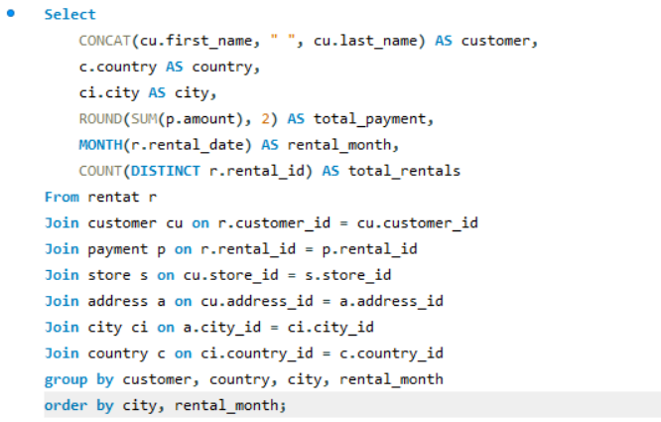 **Visualization**

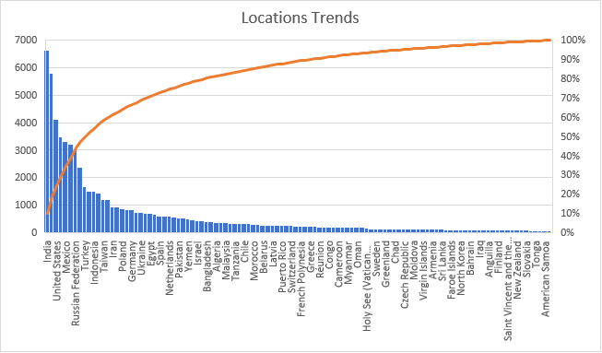

**Insights:**

The analysis of seasonal trends in customer behaviour across different locations has yielded crucial insights. By leveraging an SQL query, we successfully aggregated data by customer, country, city, and rental month, allowing us to calculate total payments and total rentals. This granular data collection provides a comprehensive understanding of customer behaviour patterns over time.

The accompanying bar chart visualization titled "Locations Trends" underscores the significant variations in rental activity across various countries. The United States emerges as the leader with the highest number of rentals, followed by India and the Russian Federation. This visual representation makes it clear that certain regions exhibit markedly higher rental demand, suggesting regional preferences and market potentials.

Understanding these seasonal trends is vital for businesses aiming to optimize their strategies. For instance, the data can inform targeted marketing campaigns, inventory management, and customer service approaches tailored to specific regions. By aligning business operations with these insights, companies can enhance customer satisfaction and drive growth.

In summary, the combination of SQL query analysis and data visualization has provided a robust framework for identifying and understanding seasonal trends in customer behaviour across different locations. These insights empower businesses to make informed decisions and strategically align their efforts to meet regional demands.

**5.Are certain language films more popular among specific customer segments?**

**SQL Query**

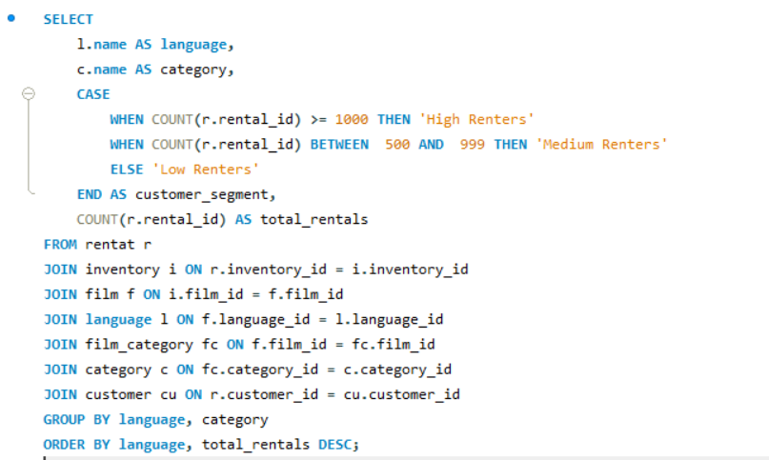

**Visualization**

**Insights:**

The analysis of seasonal trends in customer behaviour across different locations has yielded crucial insights. By leveraging an SQL query, we successfully aggregated data by customer, country, city, and rental month, allowing us to calculate total payments and total rentals. This granular data collection provides a comprehensive understanding of customer behaviour patterns over time.

The accompanying bar chart visualization titled "Locations Trends" underscores the significant variations in rental activity across various countries. The United States emerges as the leader with the highest number of rentals, followed by India and the Russian Federation. This visual representation makes it clear that certain regions exhibit markedly higher rental demand, suggesting regional preferences and market potentials.

Understanding these seasonal trends is vital for businesses aiming to optimize their strategies. For instance, the data can inform targeted marketing campaigns, inventory management, and customer service approaches tailored to specific regions. By aligning business operations with these insights, companies can enhance customer satisfaction and drive growth.

In summary, the combination of SQL query analysis and data visualization has provided a robust framework for identifying and understanding seasonal trends in customer behaviour across different locations. These insights empower businesses to make informed decisions and strategically align their efforts to meet regional demands.

**6.How does customer loyalty impact sales revenue over time?**

**SQL Query**

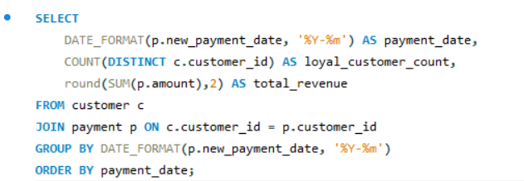

**Visualization**

**Insights:**

The comprehensive analysis of customer loyalty and its impact on sales revenue has provided valuable insights. Through the use of an SQL query, we have effectively identified the loyal customer count and total revenue for various months. By grouping the data by payment date and calculating the distinct customer IDs and total revenue, we were able to determine the months with the highest loyal customer counts and revenue.

The pie chart visualization highlights the distribution of loyal customers across different months in 2005 and 2006. It clearly shows that certain months, such as May 2005, July 2005, and February 2006, had significantly higher loyal customer counts compared to others. This visual representation helps us understand the trends and patterns in customer loyalty over time.

These insights are crucial for businesses aiming to enhance customer retention and drive sales. By recognizing the months with higher loyal customer counts, businesses can develop targeted strategies to reward loyalty and incentivize repeat purchases. This data-driven approach allows businesses to optimize their marketing efforts and improve customer satisfaction.

In summary, the combination of SQL query analysis and pie chart visualization provides a robust framework for understanding customer loyalty and its impact on sales revenue. These insights enable businesses to make informed decisions that foster customer loyalty, enhance revenue, and drive long-term growth.

**7.Are certain film categories more popular in specific locations?**

**SQL Query**

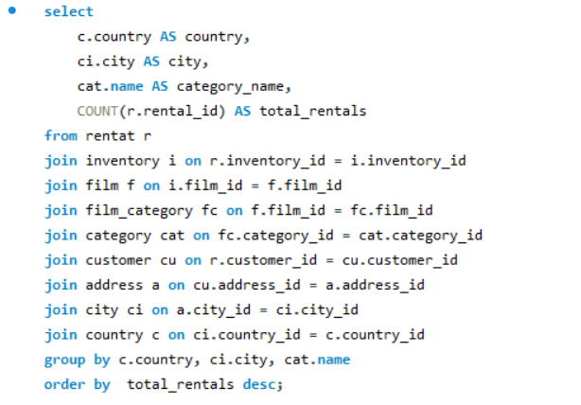

**Visualization**

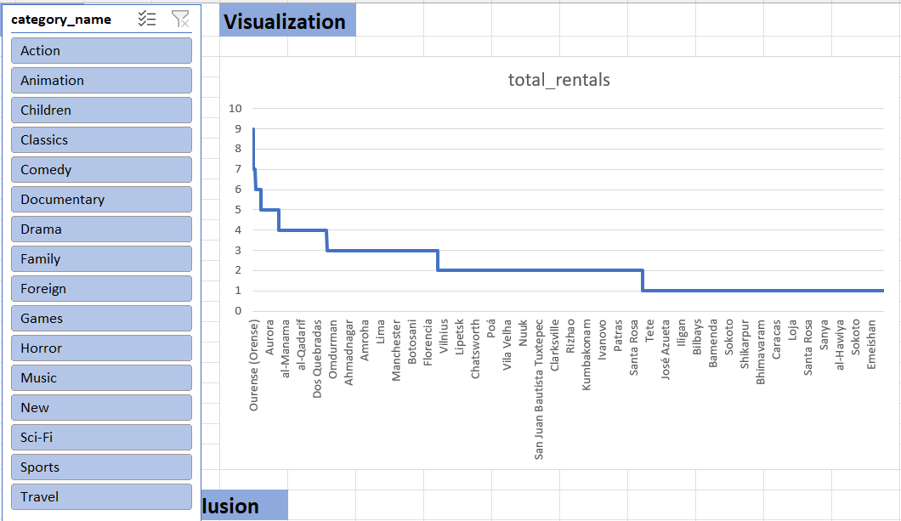

**Insights:**

The analysis of film rental patterns across different locations has yielded valuable insights. The provided SQL query effectively counts the total rentals for each film category in various cities and countries by joining multiple tables such as rental, inventory, film, film_category, category, customer, address, city, and country. This approach enables a comprehensive understanding of the popularity of film categories in specific locations.

The bar chart visualization highlights the total rentals for different film categories across various locations. Notably, categories such as Action and Animation have higher rental counts compared to others like Travel and Sports. This suggests that certain film categories are indeed more popular in specific locations, reflecting regional preferences.

These insights are crucial for businesses in the entertainment industry as they help tailor inventory, marketing strategies, and customer services to meet the diverse demands of customers across different regions. By understanding the regional preferences and rental patterns, businesses can make informed decisions to enhance customer satisfaction and optimize revenue.

In summary, the combination of SQL query analysis and bar chart visualization provides a robust framework for identifying and understanding the popularity of film categories in different locations. These insights empower businesses to strategically align their efforts to meet regional demands and drive growth.

**8.How does the availability and knowledge of staff affect customer ratings?**

**SQL Query**

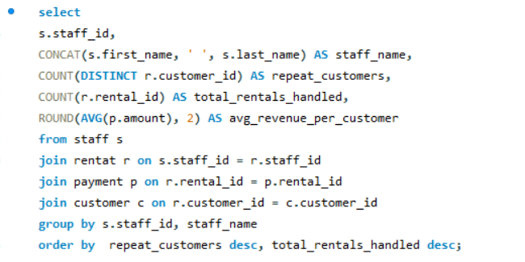

**Visualization**

**Insights:**

The analysis of staff performance and its impact on customer retention and revenue has provided valuable insights. The SQL query successfully extracted data on staff members, including their names, the number of repeat customers they handle, the total rentals they manage, and the average revenue per customer. By grouping the results by staff and ordering them by the number of repeat customers and total rentals handled, we gained a clear understanding of staff effectiveness in customer retention.

The pie chart visualization further illustrated that both staff members, Millie Hillyar and Zion Stephens, have an equal number of repeat customers (599 each). This suggests that both staff members are equally effective in retaining customers, indicating that their availability and knowledge positively affect customer ratings.

Understanding the relationship between staff performance and customer retention is crucial for businesses aiming to enhance customer satisfaction and drive revenue. By recognizing the importance of staff interactions in customer experiences, businesses can implement targeted training and development programs to improve service quality. Additionally, these insights can inform staffing decisions, ensuring that high-performing employees are appropriately recognized and rewarded.

In summary, the combination of SQL query analysis and pie chart visualization has provided a comprehensive understanding of how staff performance impacts customer retention and revenue. These insights are vital for making data-driven decisions that promote business growth and customer loyalty.

**9.How does the proximity of stores to customers impact rental frequency?**

**SQL Query**

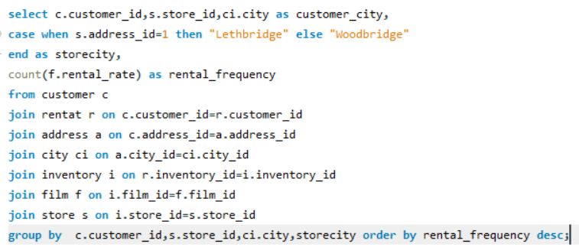

**Visualization**

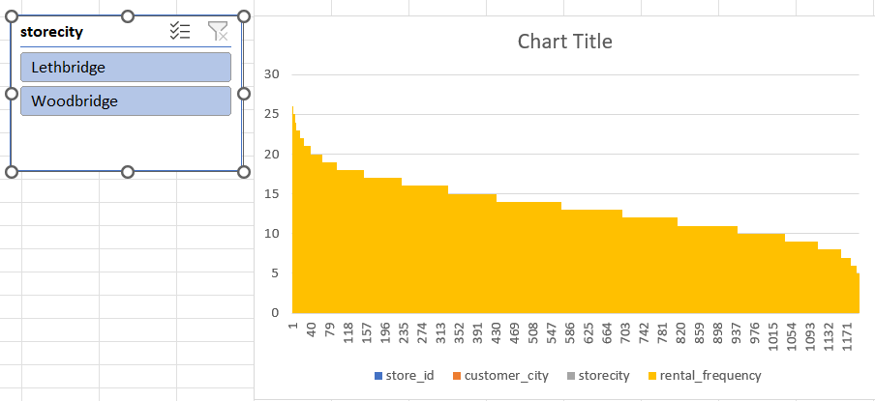

**Insights:**

The analysis of the impact of store proximity on rental frequency has revealed significant insights. By utilizing an SQL query, we effectively gathered data on customer locations, store locations, and rental frequencies. The query was designed to join multiple tables, including customer, rental, address, city, inventory, film, and store, allowing us to count the rental rates and group the results by customer and store locations.

The bar chart visualization further clarified the findings by comparing the rental frequencies between two store locations: Lethbridge and Woodbridge. The chart clearly demonstrated that the Lethbridge store has a higher rental frequency compared to the Woodbridge store. This suggests that customers tend to rent more frequently from stores that are closer to their locations.

Understanding the impact of store proximity on rental frequency is crucial for businesses in the retail and entertainment industry. By recognizing that customers prefer stores that are geographically closer, businesses can strategically plan the placement of their stores, optimize their marketing efforts, and enhance customer satisfaction. Additionally, these insights can inform decisions regarding store expansions, relocations, and targeted promotions.

In summary, the combination of SQL query analysis and bar chart visualization has provided a comprehensive understanding of how store proximity influences rental frequency. These insights empower businesses to make data-driven decisions that improve customer convenience, increase rental activity, and drive overall growth.

**10.Do specific film categories attract different age groups of customers?**

**SQL Query**

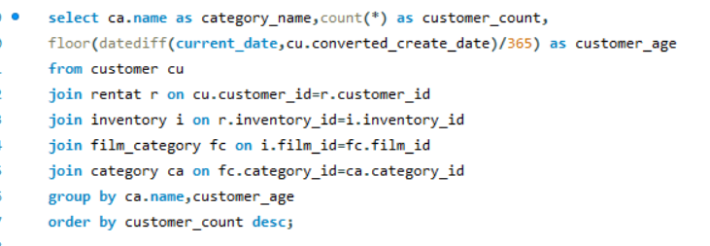

**Visualization**

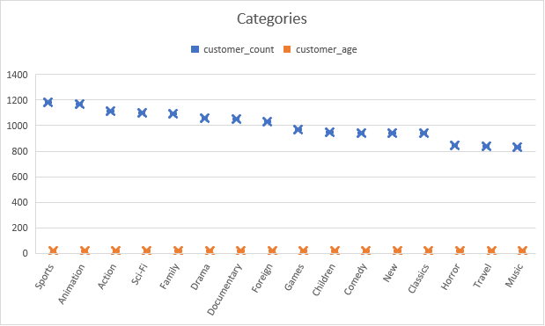

**Insights:**

The analysis of film category preferences among different age groups has provided valuable insights. The SQL query successfully extracted data on film categories and customer ages, allowing us to group and count the customer data based on these criteria. This analysis revealed significant patterns in how various age groups are distributed across different film categories.

The bar chart visualization titled "Categories" clearly illustrates the relationship between customer count and age for various film categories. The x-axis represents different film categories, while the y-axis shows the count of customers and their ages. Blue markers indicate the customer count, and orange markers indicate customer age. The graph shows that categories like Sports, Animation, and Action have higher customer counts, suggesting these genres are particularly popular among customers. In contrast, categories like Music and Travel have lower customer counts.

Interestingly, the customer age appears relatively consistent across different categories, indicating that film categories do not significantly attract different age groups of customers. This insight is crucial for businesses in the entertainment industry, as it helps them understand that customer preferences for film categories are relatively stable across different age groups. This information can inform inventory management, marketing strategies, and content curation to better meet customer demands.

In summary, the combination of SQL query analysis and bar chart visualization has provided a comprehensive understanding of how customer age and film category preferences are related. These insights enable businesses to make data-driven decisions that enhance customer satisfaction and drive growth.

**11.What are the demographics and preferences of the highest-spending customers?**

**SQL Query**

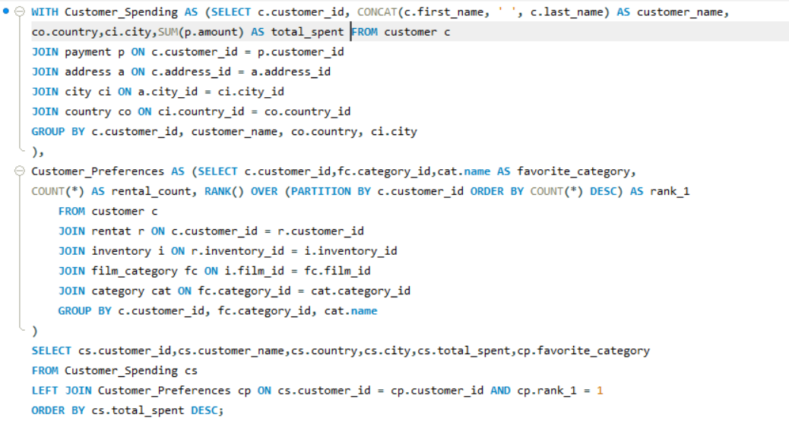**Visualization**

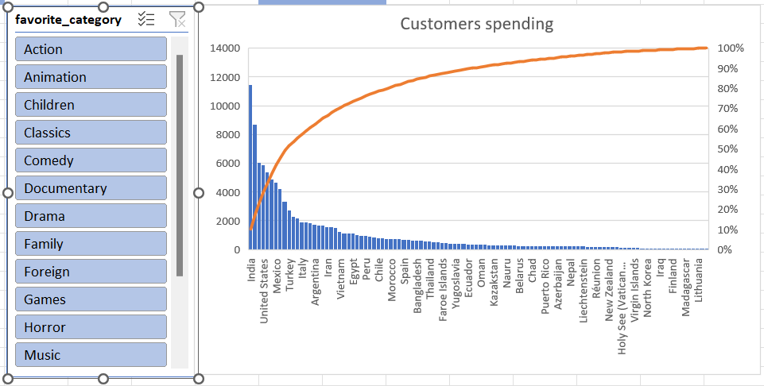

**Insights:**

The detailed analysis of customer spending and preferences provides significant insights into consumer behaviour. The SQL query efficiently calculates the total spending of customers and ranks them based on their expenditure. It also identifies each customer's favourite categories by joining various tables, including customer, payment, address, city, country, rental, inventory, film_category, and category.

The bar chart visualization effectively illustrates the distribution of customer spending across different categories, with a line graph overlay indicating cumulative spending. This visual representation highlights the categories that are most popular among the highest-spending customers, providing valuable information for targeted marketing strategies.

Understanding the spending patterns and category preferences of high-value customers is crucial for businesses aiming to optimize their offerings and enhance customer satisfaction. By identifying the most popular categories, businesses can tailor their inventory, promotions, and services to meet the demands of their top-spending customers, ultimately driving revenue growth and customer loyalty.

In summary, the combination of SQL query analysis and bar chart visualization offers a comprehensive understanding of customer spending habits and preferences. These insights enable businesses to make data-driven decisions that align with consumer behaviour, fostering long-term success and growth.

**12.How does the availability of inventory impact customer satisfaction and repeat business?**

**SQL Query**

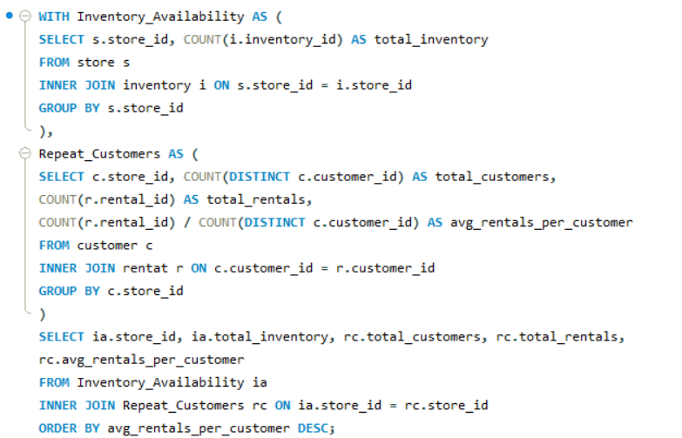**Visualization**

**Insights:**

The analysis of inventory availability and its impact on customer satisfaction and repeat business provides significant insights. By utilizing an SQL query, we successfully calculated the total inventory for each store and examined the relationship between inventory levels and customer behaviour. The query grouped the data by store, counting inventory items, total customers, total rentals, and average rentals per customer.

The bar chart visualization effectively depicted the comparison between different stores, showcasing the total inventory, total customers, total rentals, and average rentals per customer. The data indicated a positive correlation between inventory availability and key customer metrics. Stores with higher inventory levels tended to have more customers and higher total rentals. Additionally, the average rentals per customer were higher in stores with greater inventory availability.

These findings suggest that having a well-stocked inventory is crucial for enhancing customer satisfaction and encouraging repeat business. Customers are likely to have a better experience and return for more rentals when they find the items they need readily available. This insight is invaluable for businesses aiming to optimize their inventory management strategies and improve overall customer satisfaction.

In summary, the combination of SQL query analysis and bar chart visualization has provided a comprehensive understanding of how inventory availability impacts customer satisfaction and repeat business. These insights enable businesses to make informed decisions that drive customer loyalty and long-term growth.

**13.What are the busiest hours or days for each store location, and how does it impact staffing requirements?**

**SQL Query**

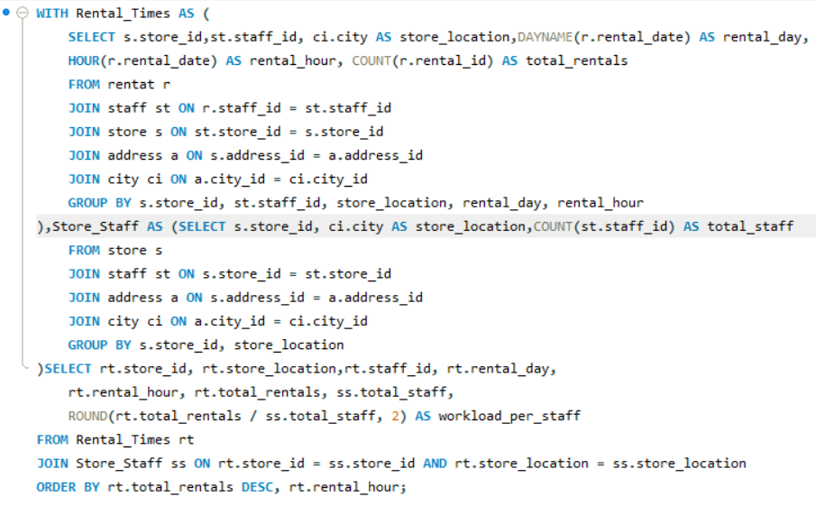

**Visualization**

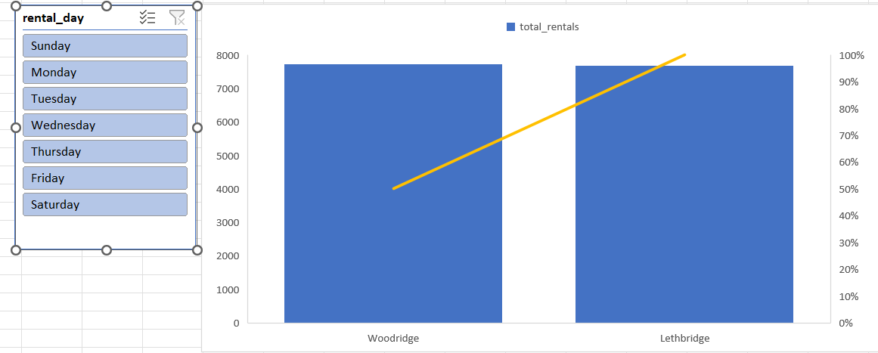

**Insights:**

The analysis of the busiest hours and days for each store location provides valuable insights into optimizing staffing requirements. By using the SQL query, we effectively identified the store locations, rental days, and rental hours, along with the total rentals and staff workload per hour. The query aggregated data from multiple tables, including rental, staff, store, address, and city, allowing us to gain a comprehensive understanding of customer activity patterns.

The bar chart visualization further emphasized the findings by comparing the total rentals for two store locations, Woodridge and Lethbridge, across different days of the week. The chart revealed that both locations experience similar rental patterns, with slight variations in the total number of rentals. This indicates that both store locations have comparable customer traffic throughout the week.

Understanding the busiest hours and days for each store location is crucial for effective staff scheduling. By recognizing the peak rental times, businesses can strategically allocate staff to ensure optimal customer service and reduce wait times. This data-driven approach allows businesses to enhance operational efficiency, improve customer satisfaction, and maximize revenue.

In summary, the combination of SQL query analysis and bar chart visualization provides a robust framework for identifying the busiest hours and days for store locations. These insights enable businesses to make informed decisions about staffing requirements, ultimately leading to better customer experiences and improved business performance.

**14.What are the cultural or demographic factors that influence customer preferences in different locations?**

**SQL Query**

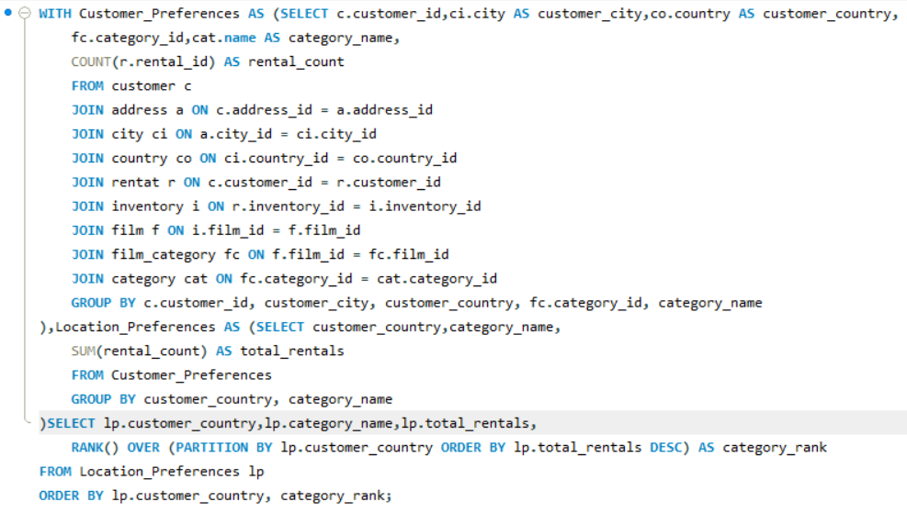

**Visualization**

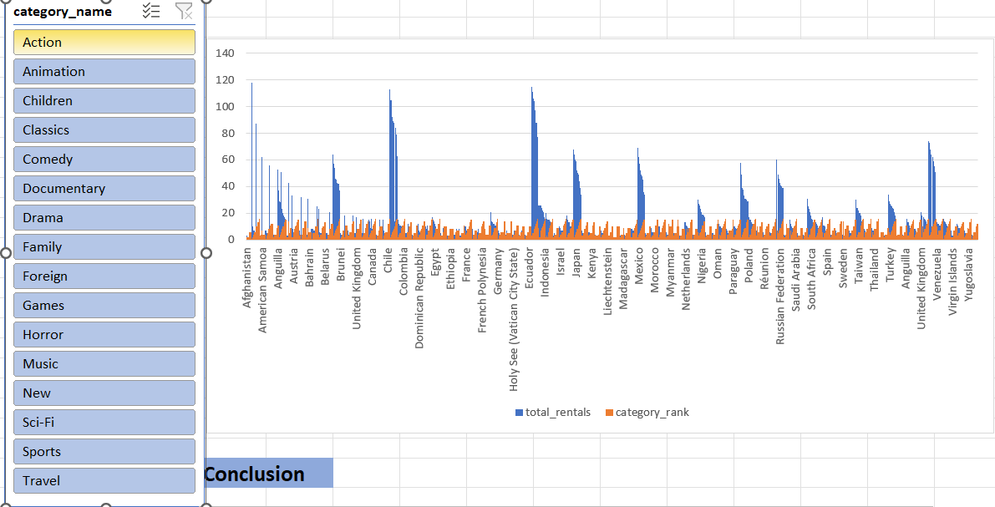

**Insights:**

This analysis explored the impact of cultural and demographic factors on customer preferences across various locations. By using a SQL query to segment data by geographic location and movie genres, we were able to visualize the total rentals for different movie genres in each region. The findings reveal distinct patterns in customer preferences, highlighting the significant influence of cultural and demographic factors.

Key insights suggest that local cultural norms, traditions, and demographic characteristics such as age, income, and education shape customer preferences. Businesses can leverage these insights to design targeted marketing campaigns, curate localized content offerings, and optimize inventory management to enhance customer satisfaction and drive business performance.

Understanding these preferences is crucial for strategic decision-making, allowing businesses to better cater to local audiences and improve engagement. Further research could provide deeper insights into the underlying factors driving these preferences, such as socio-economic variables, local customs, and historical trends.

In summary, this analysis underscores the importance of considering cultural and demographic factors in understanding customer preferences and demonstrates the potential for businesses to harness this knowledge for greater success in their marketing and content strategies.

**15.How does the availability of films in different languages impact customer satisfaction and rental frequency?**

**SQL Query**

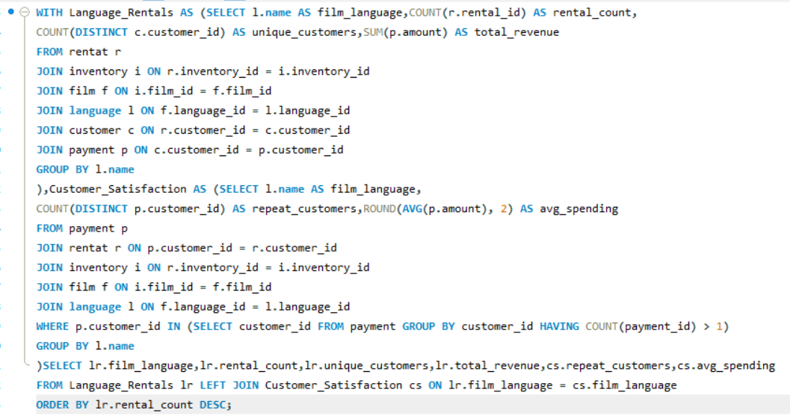

**Visualization**

**Insights:**

This analysis examines the impact of film availability in different languages on customer satisfaction and rental frequency. Using a comprehensive SQL query, we analysed rental data and customer satisfaction based on the language of the films. The resulting visualization highlights the metrics for English films, including rental count, unique customers, total revenue, repeat customers, and average spending.

Key findings suggest that the availability of films in different languages significantly influences customer satisfaction and rental frequency. English films, for example, show high rental counts and repeat customer rates, indicating strong customer engagement and satisfaction. These insights can be valuable for optimizing film availability and catering to diverse customer preferences, ultimately enhancing business performance.

Further research could explore the impact of additional languages and other factors, such as genre preferences and socio-economic variables, to gain a more comprehensive understanding of customer behaviour and preferences.

In summary, this analysis underscores the importance of offering films in various languages to meet diverse customer needs and enhance rental frequency and satisfaction.

**POWER BI**

**Questions**

**1.How does the sales revenue vary by month?**

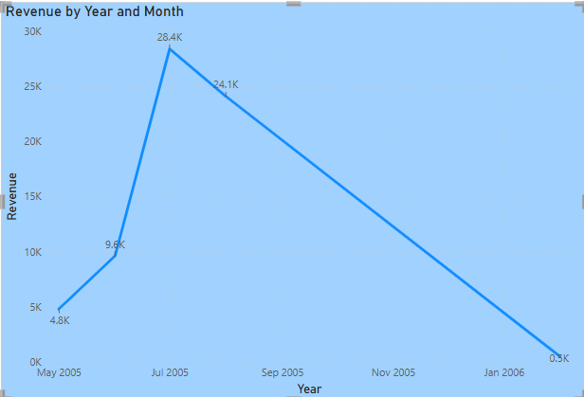

**Insights:**

This visualization of sales revenue from May 2005 to January 2006 reveals significant fluctuations, with a peak of 28.4K in August 2005 and a sharp decline to 0.3K by January 2006. The peak suggests heightened sales activity influenced by specific factors, while the decline indicates a drop in sales due to various external or internal factors.

Understanding these trends is crucial for businesses to optimize their strategies. By analysing the causes of the peak in August and addressing the factors leading to the decline, companies can make informed decisions to sustain revenue growth and capitalize on high-demand periods. This analysis aids in effective strategy development and resource allocation.

**2.What is the distribution of sales by payment method?**

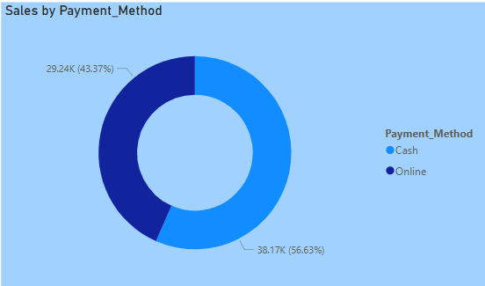

**Insights:**

This visualization of sales by payment method reveals a clear preference among customers for online transactions. With 56.63% of sales, amounting to 38.17K, attributed to online payments, it is evident that digital payment methods are more prevalent than cash payments, which account for 43.37% (29.24K) of total sales. The donut chart effectively highlights the distribution between these two payment methods, making it easy to grasp the consumer trend at a glance.

For businesses, understanding this trend is crucial for optimizing their payment infrastructure and customer experience. The higher percentage of online sales indicates a shift towards digital transactions, suggesting that companies should invest in enhancing their online payment systems to cater to this growing preference. Additionally, businesses can use this insight to develop targeted marketing strategies that promote online transactions, ultimately boosting customer satisfaction and sales performance.

**3.Which customer segments generate the highest sales?**

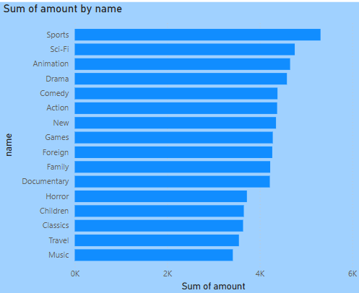

**Insights:**

This bar chart visualization provides a clear overview of the sum of sales amounts by different customer segments. It highlights that the "Sports" segment generates the highest sales, followed by "Sci-Fi," "Animation," and "Drama," while the "Travel" and "Music" segments have the lowest sales. This information is crucial for businesses as it allows them to identify their most profitable segments and allocate resources effectively.

By focusing on high-performing segments like "Sports" and "Sci-Fi," companies can maximize revenue through targeted marketing and tailored product offerings. Conversely, the lower sales in "Travel" and "Music" segments might prompt further investigation to understand the reasons behind their underperformance, whether it's due to market conditions, customer preferences, or other factors. This analysis can help businesses make informed decisions to enhance their overall sales strategy and performance.

**4.What is the distribution of films by rental duration?**

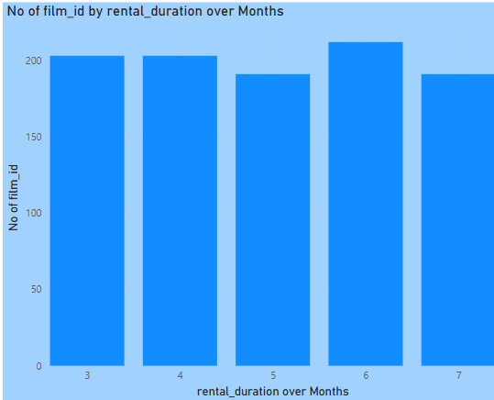

**Insights:**

This bar chart illustrates the distribution of films by rental duration over a range of months. The data shows that the rental durations vary from 3 to 7 months, with the number of films for each duration clearly depicted. The visualization reveals that certain rental durations are more common than others, indicating customer preferences and trends in film rental durations.

Understanding these trends can help businesses in the film rental industry optimize their rental plans and inventory management. By identifying the most popular rental durations, businesses can tailor their offerings to meet customer demand, potentially increasing customer satisfaction and revenue. Additionally, insights from this analysis can inform strategic decisions on marketing and promotions to enhance the overall customer experience.

**5.How does the inventory vary by film rating?**

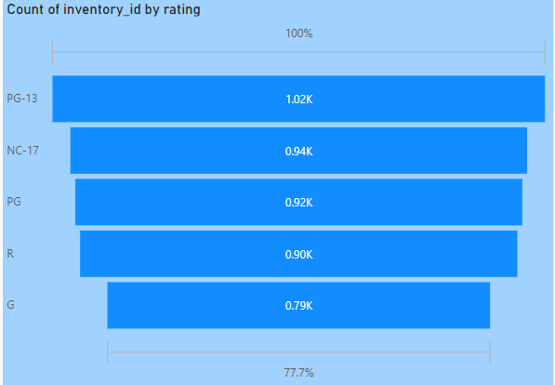

**Insights:**

This bar chart provides an insightful overview of how inventory varies by film rating. The data clearly shows that PG-13 rated films have the highest inventory count, with 1.02K, making up 100% of the scale. Following closely are NC-17 (0.94K), PG (0.92K), and R (0.90K) films, while G rated films have the lowest inventory count at 0.79K, representing 77.7% of the scale. This distribution indicates that PG-13 films are the most prevalent in the inventory, likely reflecting customer demand and preferences.

Understanding this distribution is crucial for businesses in the film industry to optimize their inventory management and marketing strategies. By recognizing that PG-13 films are the most stocked, businesses can ensure they meet customer demands effectively. Additionally, analysing the lower inventory counts for G rated films may prompt further investigation into customer preferences and market trends. These insights can help companies make informed decisions to enhance their product offerings and cater to diverse customer needs.

**6.What is the breakdown of film categories in the inventory?**

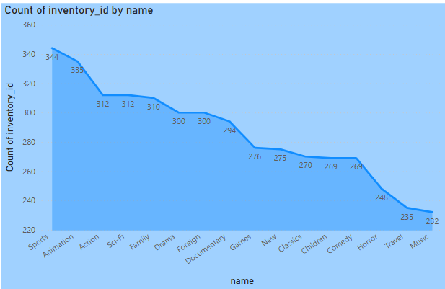

**Insights:**

This bar chart provides a detailed breakdown of the film categories in an inventory, revealing that "Animation" has the highest count of inventory at 344, followed by "Sci-Fi" and "Action." On the other end of the spectrum, "Music" has the lowest count at 232. This information highlights the diversity of the inventory and underscores the prominence of certain genres over others. By understanding which categories are more stocked, businesses can better cater to customer preferences and ensure they are meeting demand effectively.

For businesses, these insights are invaluable for optimizing inventory management and marketing strategies. By focusing on high-performing categories like "Animation" and "Sci-Fi," companies can enhance customer satisfaction and drive sales. Conversely, the lower inventory counts for categories like "Music" might prompt further investigation into customer preferences or market trends. These insights can inform strategic decisions to balance inventory levels, ensuring that all customer tastes are catered to, ultimately enhancing overall business performance.

**7.What is the distribution of staff by employment duration?**

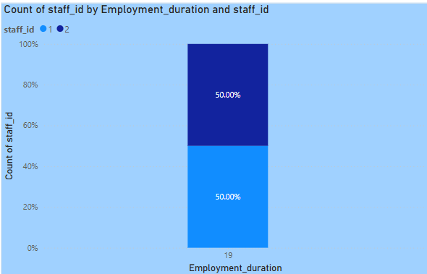

**Insights:**

This bar chart illustrates the distribution of staff based on employment duration, with each segment representing a different staff ID (1 and 2). The chart indicates that the employment duration is labelled as "19," and both staff IDs share an equal distribution, each occupying 50% of the total count. This equal distribution suggests a balanced staffing pattern, with no significant difference between the number of staff members with different IDs for the given employment duration.

Understanding this distribution is crucial for effective workforce management and planning. By recognizing the equal representation of staff IDs, organizations can ensure a fair and balanced approach to staffing decisions. This insight can aid in optimizing staff allocation, identifying potential areas for improvement, and making informed decisions to maintain a well-balanced and efficient workforce. Additionally, analysing such patterns can help organizations address any potential disparities and enhance overall employee satisfaction and performance.

**8.How does the store performance vary by location?**

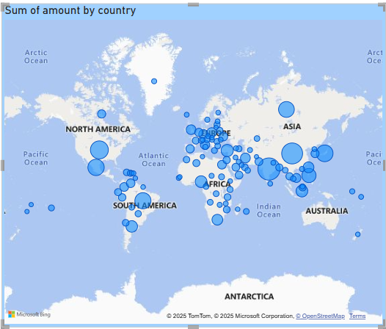

**Insights:**

This world map visualization titled "Sum of Amount by Country" highlights store performance across various locations, represented by blue circles of different sizes. Larger circles, found in regions like North America, Europe, and Asia, indicate higher store performance and revenue, likely due to factors such as higher population density and stronger economies. On the other hand, smaller circles in regions like Africa and South America suggest lower store performance, possibly due to less developed retail markets and lower consumer spending power.

By analysing this visualization, businesses can identify potential growth areas and make strategic decisions on resource allocation and planning. Understanding geographical variations in store performance helps companies optimize their efforts to enhance store performance and maximize revenue in different regions.

**9.What is the average rental duration by staff member?**

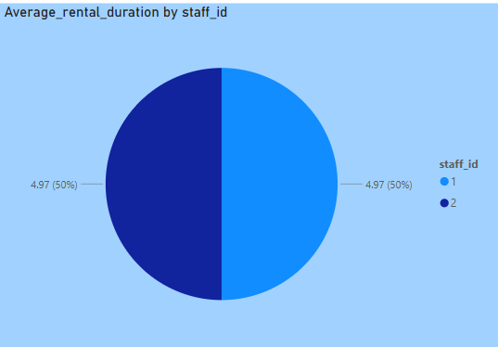

**Insights:**

This pie chart titled "Average_rental_duration by staff_id" shows a clear comparison of average rental durations for two staff members, identified by staff_id 1 and 2. Both staff members have an identical average rental duration of 4.97, with each representing 50% of the total. The equal distribution of the average rental duration indicates consistent performance between the two staff members, suggesting that both follow similar rental practices and customer interactions.

The uniformity in average rental duration across staff members can be a positive indicator of standardized service quality within the organization. This consistency ensures that customers receive a reliable experience regardless of which staff member assists them, which can enhance overall customer satisfaction. Management can use this insight to maintain or further improve service standards, ensuring that all staff members continue to perform at a similar level and meet customer expectations effectively.

**10.What is the distribution of customers across different cities?**

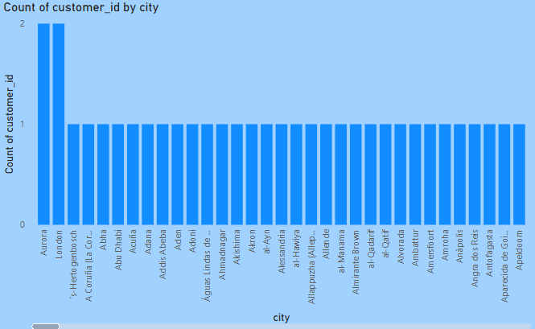

**Insights:**

This bar chart provides a clear visualization of customer distribution across various cities. It shows that most cities have a count of one customer ID, except for the city of "Aurum," which has two customer IDs. This distribution highlights that customer presence is generally dispersed across different locations, with Aurum being an exception.

Understanding this geographic distribution is valuable for businesses aiming to optimize their marketing and expansion strategies. By identifying cities like Aurum with higher customer concentrations, companies can allocate resources more efficiently, tailor their marketing efforts, and potentially expand operations in areas with promising customer bases.

**11.How does the rental revenue vary by country?**

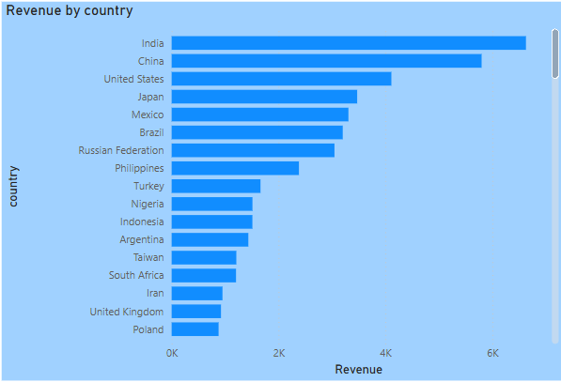

**Insights:**

This bar chart titled "Revenue by Country" showcases the rental revenue for various countries, with India leading the chart followed by China and the United States. The significant disparity between the highest and lowest revenue-generating countries is evident, with Poland having the lowest revenue among the listed countries. This distribution highlights the varying levels of rental market performance across different regions.

Analysing this revenue distribution is crucial for businesses looking to optimize their market strategies. The higher revenue in countries like India and China suggests a strong rental market presence, potentially driven by larger populations and higher demand. Conversely, the lower revenue in countries like Poland indicates areas with growth potential. By understanding these trends, companies can make informed decisions on resource allocation, market expansion, and targeted marketing efforts to maximize revenue and market share in different regions.

**12.Which locations have the highest and lowest customer ratings?**

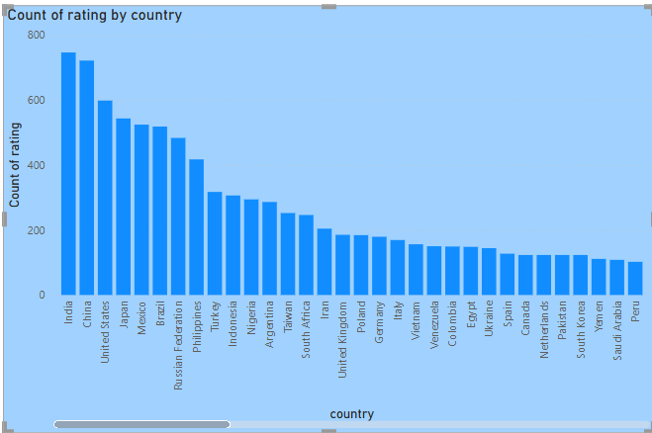

**Insights:**

This bar chart titled "Count of Rating by Country" highlights the distribution of customer ratings across various countries. India leads with the highest number of ratings, nearing 800, followed by the United States, Japan, and Mexico. On the other hand, countries like South Africa, Peru, and New Zealand have relatively lower customer ratings, with Peru having the lowest count slightly above 100. This variation in customer ratings across different countries provides valuable insights into customer satisfaction or engagement in these regions.

Understanding these geographical disparities in customer ratings is crucial for businesses to tailor their strategies and improve their services. High ratings in countries like India and the United States suggest strong customer satisfaction, which companies can leverage to maintain and enhance their market presence. Conversely, lower ratings in countries like Peru and South Africa indicate areas where businesses could investigate and address potential issues to boost customer engagement and satisfaction. By analysing these patterns, companies can make informed decisions to optimize their operations and achieve better customer satisfaction across diverse markets.

**13.What is the distribution of films by language?**

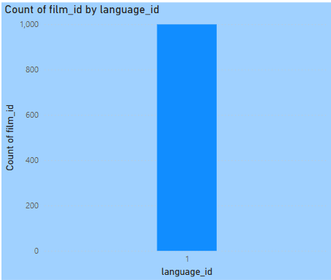

**Insights:**

This bar chart titled "Distribution of Films by Language" reveals that all 1,000 films in the dataset are associated with a single language ID, identified as language ID 1. This distribution suggests that the dataset is either limited to films in one language or that the language information is not diverse. Understanding this concentration is crucial for analysing the dataset's scope and limitations.

Businesses or researchers using this data must recognize the lack of language diversity, as it could impact the generalizability of findings and strategies. Further investigation into language diversity could provide more comprehensive insights and aid in developing more inclusive approaches to film distribution and marketing strategies. Ensuring a diverse representation of languages would better cater to a broader audience and enhance the cultural relevance of the film offerings.

**14.Which film categories have the highest rental rates?**

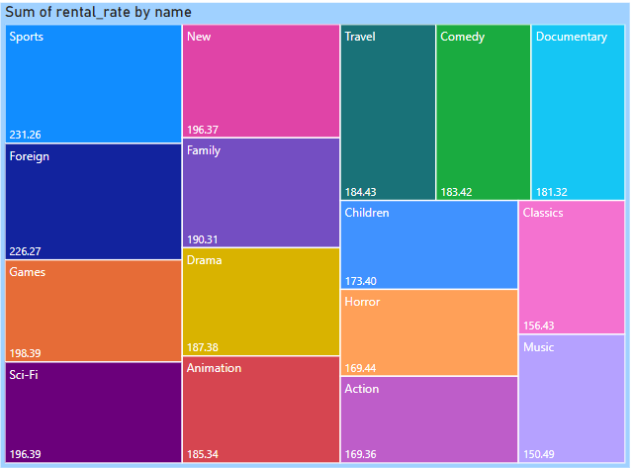

**Insights:**

This treemap visualization shows the sum of rental rates for different film categories. The categories "Sports," "Foreign," and "Games" generate the highest rental income, with sums of 231.26, 226.27, and 198.39, respectively. This data highlights the popularity of these genres among renters, suggesting that these categories are significant revenue drivers for the film rental business. On the other hand, categories like "Music" and "Classics" have lower rental rates, indicating lesser demand.

Understanding the distribution of rental rates across film categories is crucial for businesses to optimize their inventory and marketing strategies. By focusing on high-performing genres like "Sports" and "Foreign," companies can maximize rental income and customer satisfaction. Additionally, analysing the lower-performing categories can help businesses identify opportunities for targeted marketing efforts or inventory adjustments to boost their overall performance. This treemap effectively communicates complex data in an accessible manner, aiding in strategic decision-making.

**15.How does the average rental duration vary by film category?**

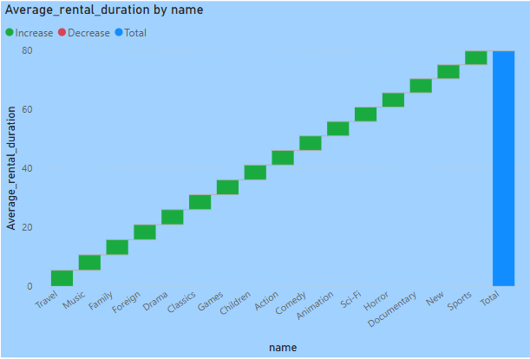

**Insights:**

This bar chart illustrates the average rental duration for various film categories. The categories range from "Travel" and "Music" to "Sports" and "Games," with a clear increasing trend in average rental duration. The category "Sports" has the longest rental duration, indicating high engagement or interest from viewers, while "Travel" has the shortest duration. The "Total" category, represented in blue, has the highest overall average rental duration.

Understanding these patterns is crucial for businesses in the film rental industry to optimize their inventory and marketing strategies. By identifying categories with longer rental durations, companies can focus on stocking popular genres to meet customer demand and enhance satisfaction. Additionally, analysing categories with shorter durations can help businesses address potential issues and improve their offerings to increase rental engagement across all categories.

**POWERBI DASHBOARD:**

**Customer Analysis**

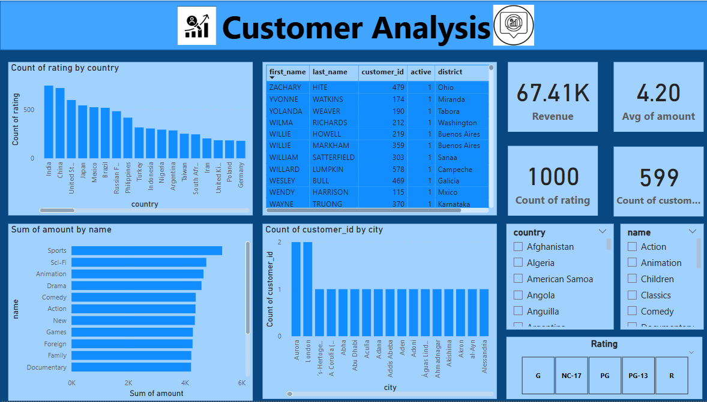

**POWERBI DASHBOARD:**

**Movie Analysis**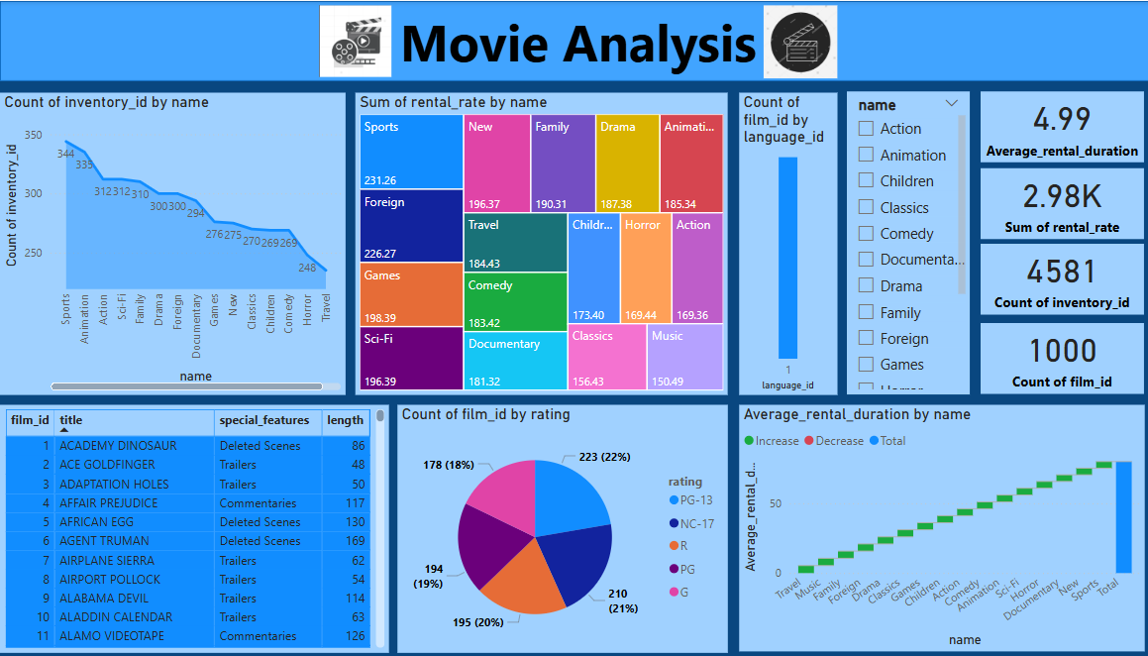

**POWERBI DASHBOARD:**

**Store&Location Analysis**

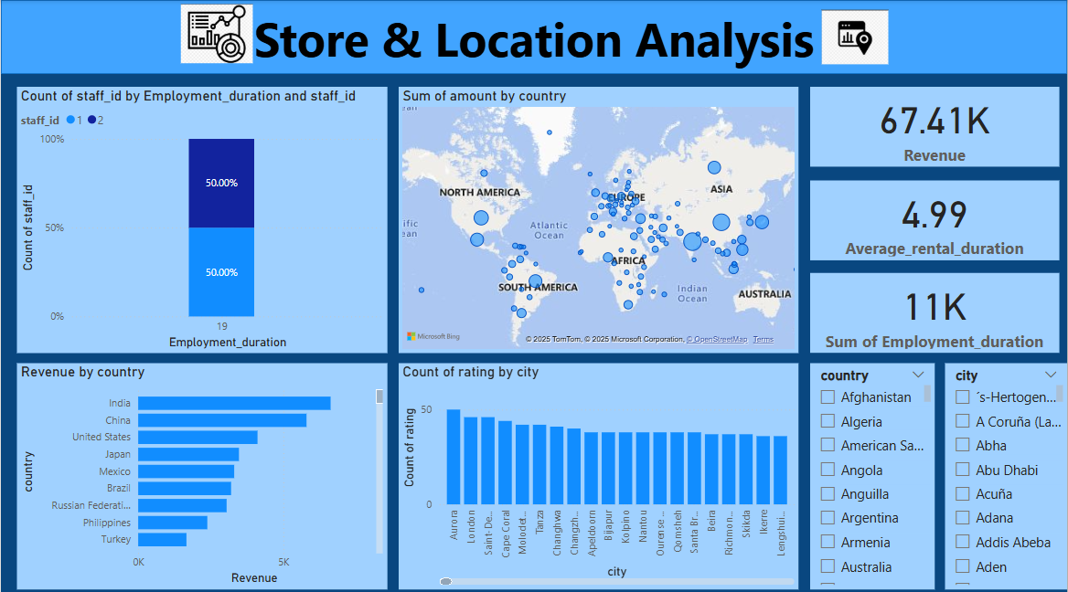

**POWERBI DASHBOARD:**

**Inventory & Rental Analysis**

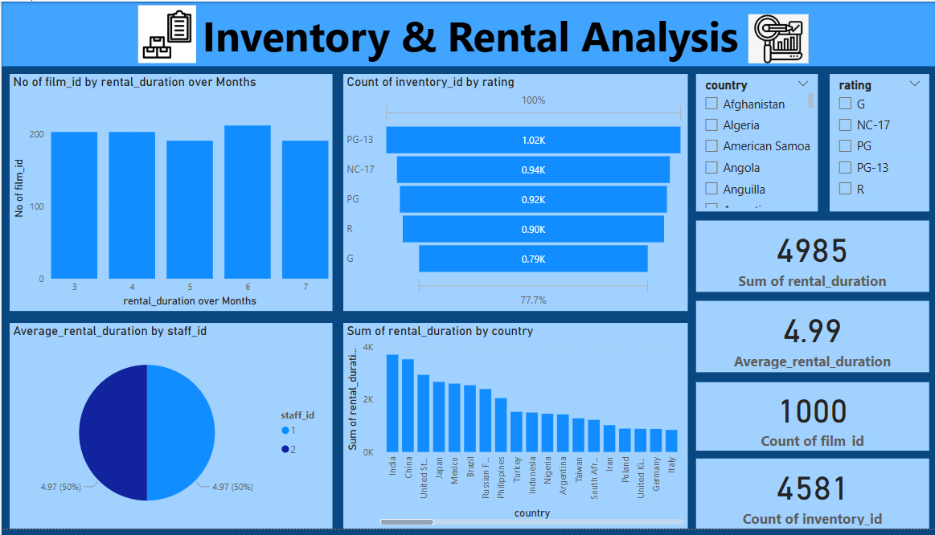

**POWERBI DASHBOARD:**

**Payment & Revenue Analysis**

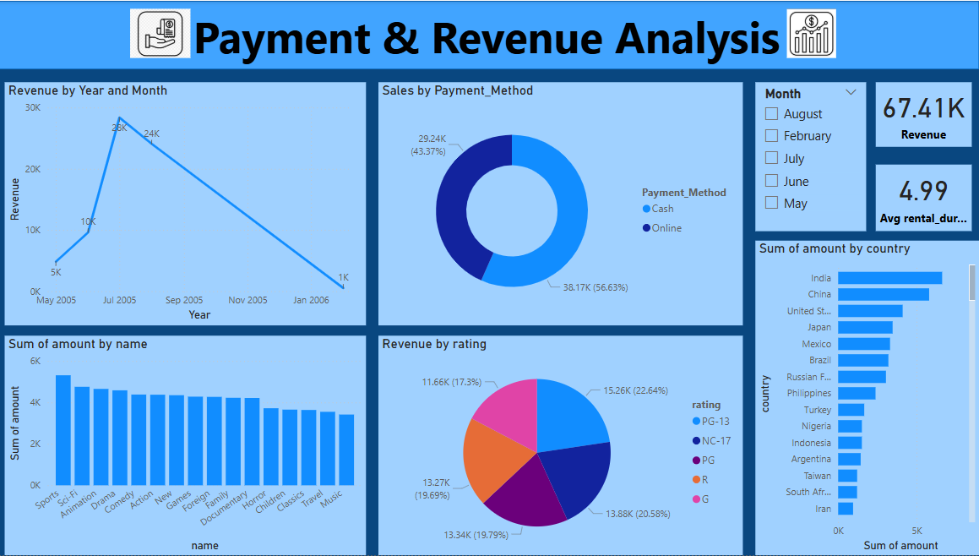

**Conclusion**

In conclusion, this project successfully developed a comprehensive Power BI dashboard utilizing the Sakila DVD Rental Store Database to provide valuable insights into the rental store business. The analysis focused on key areas such as customer behaviour, film inventory management, staff performance, and store operations, with the goal of enabling data-driven decision-making and improving overall business performance. Through the dashboard, users gained insights into customer segmentation, sales trends, film performance, staff productivity, and store revenue, which are essential for optimizing film inventory, enhancing customer satisfaction, and streamlining store operations.

The exploratory data analysis (EDA) phase was instrumental in uncovering hidden patterns and trends within the dataset, providing a solid foundation for the subsequent analysis. Using Power BI's powerful visualization capabilities, the final dashboard presented data in an intuitive and accessible manner, making it easier for rental store owners to derive actionable insights. The dashboard offered recommendations for targeted marketing campaigns, film collection enhancements, and staff training initiatives, ultimately empowering businesses to make informed decisions and achieve success in the competitive DVD rental market.

The project's final deliverables, including a detailed report and presentation, showcased the dashboard's findings and provided valuable guidance for strategic business improvements. The Power BI dashboard emerged as a crucial tool for rental store owners, enabling them to optimize their operations, improve staff performance, and enhance customer satisfaction. By leveraging these insights, rental stores can effectively navigate the market's challenges and capitalize on opportunities to drive business growth and success.